SCRIPTING

sh number_system2

sh wish



sh remove_lines

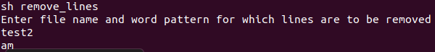



sh caseChange

**A common use of 'tr' is to convert lowercase characters to uppercase.**

**tr abcdefghijklmnopqrstuvwxyz ABCDEFGHIJKLMNOPQRSTUVWXYZ**

**tr a-z A-Z <sourcefilename> <destfilename>**

test3 file:



